1) Watch terraform-03 video.

2) Execute the script shown in video.  
  
Executed Environment variables:

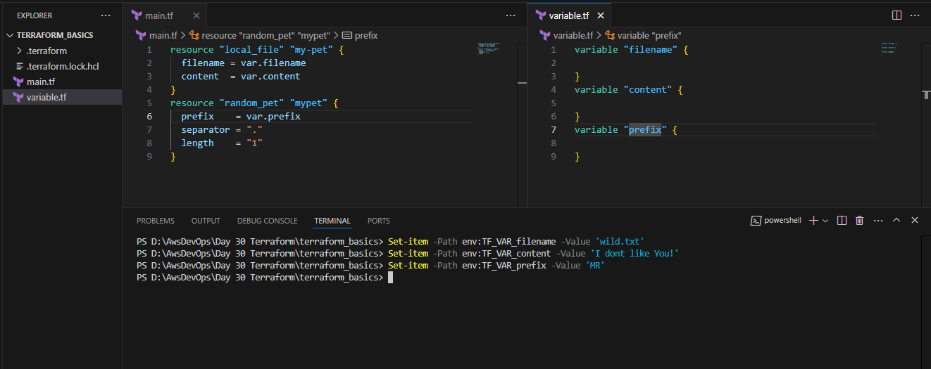

Execution complete:

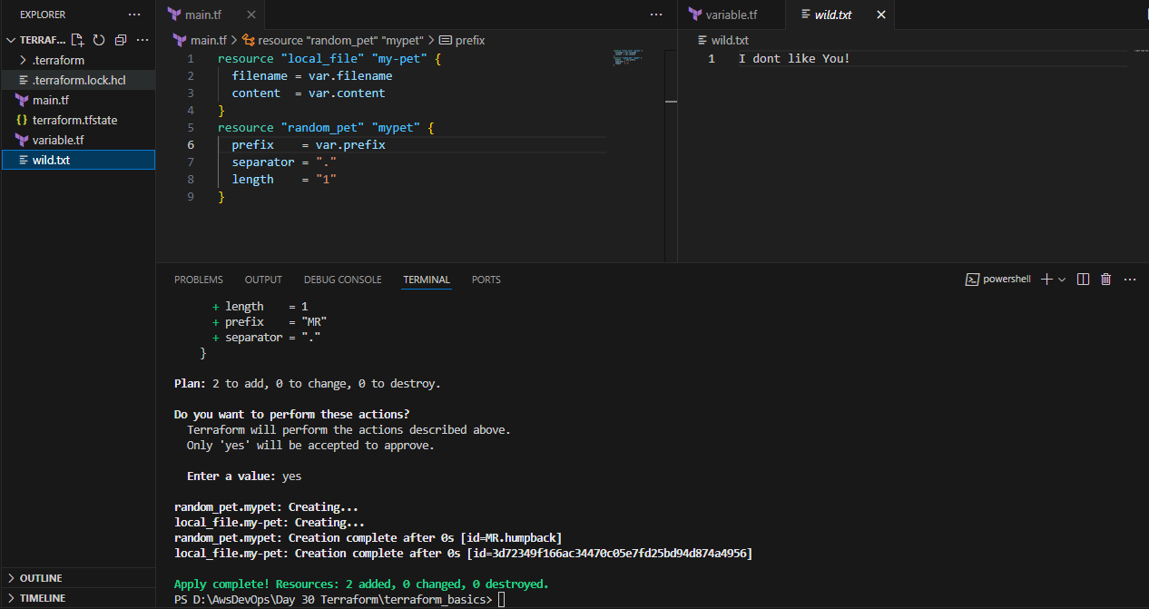

If we use multiple variables which it will select:  
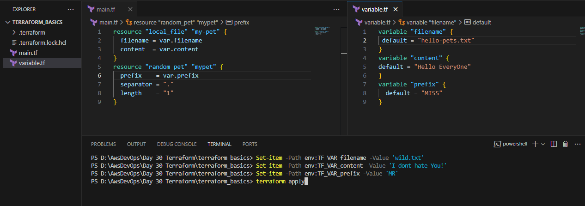

As per precedence order it has used the **FLAGS** variable:  
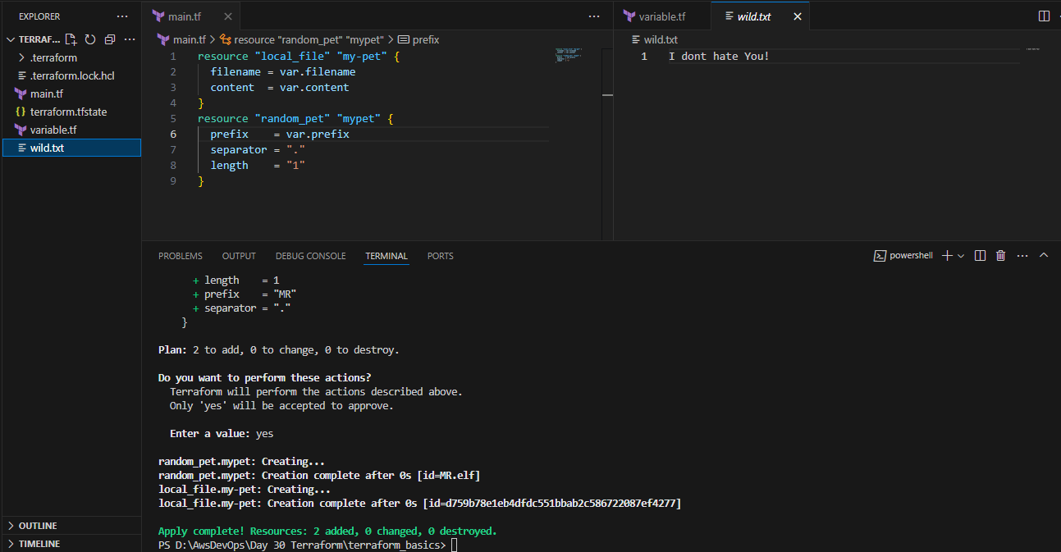

Performed terraform apply on this basis:  
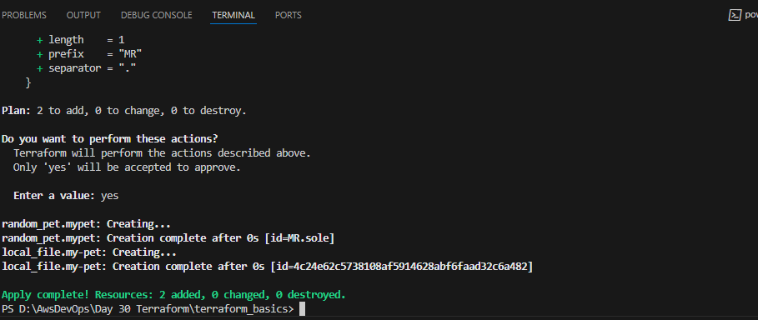

Destroyed the terraform:  
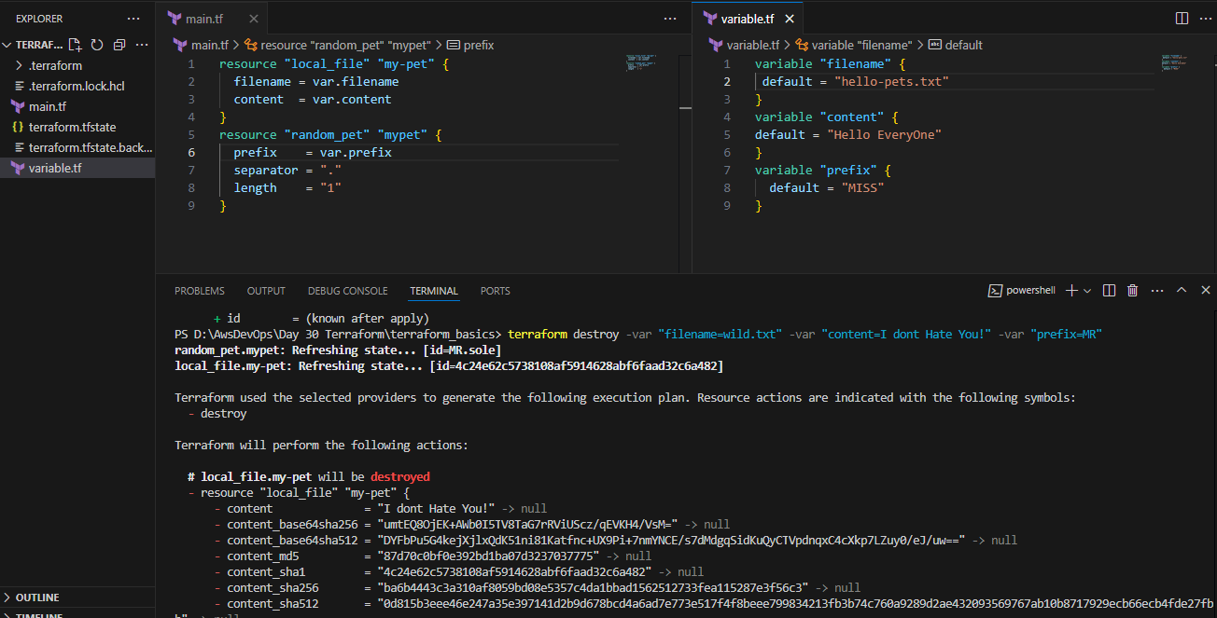

How to Provide Random_provider name in our local file:  
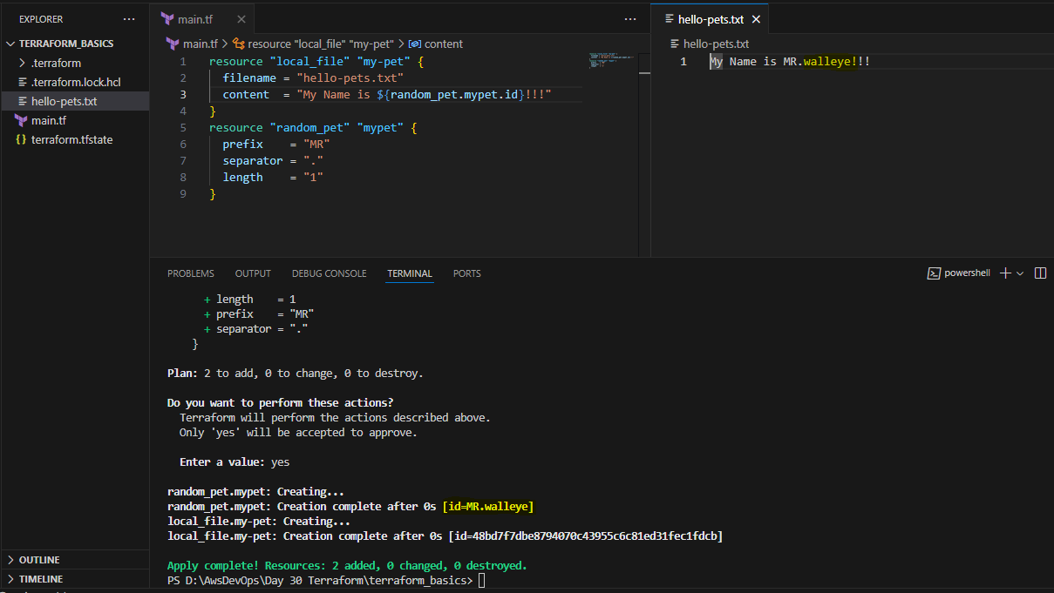

What is Terraform output: (Not the best practice to use terraform apply for the output of our file)

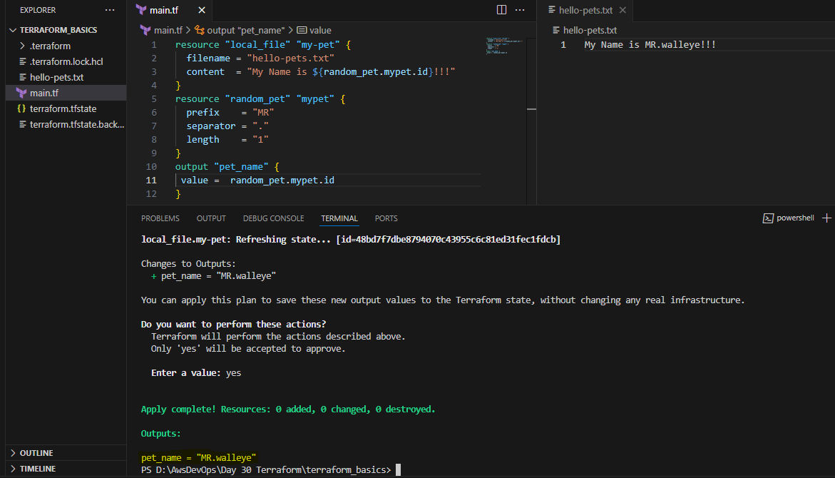

With the help of terraform output we can use it:  
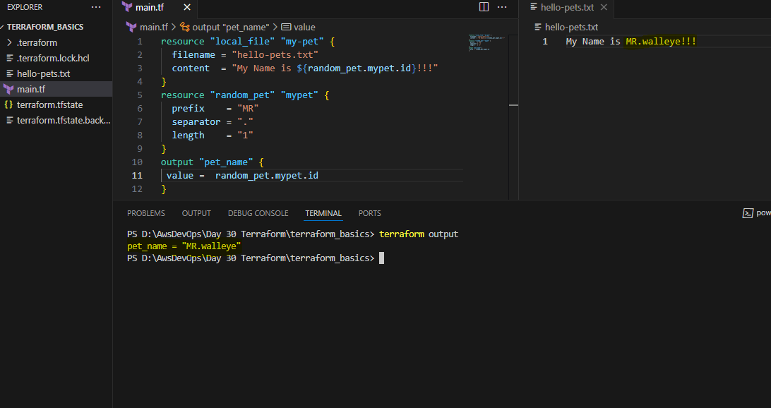

What terraform show command will do?  
it will show us the terraform.tfstate file contente. 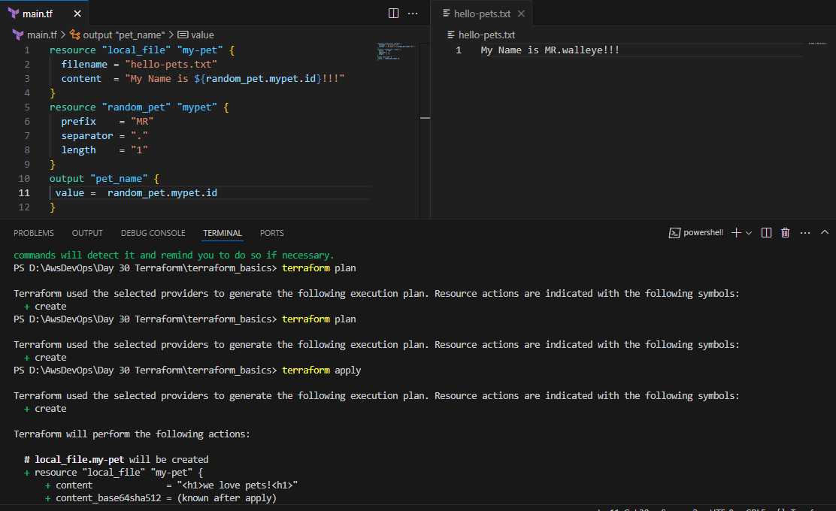

3) Intergrate terrafrom in jenkins using Terraform plugin.

Installed terraform on Jenkins CLI also added Terraform plug in in Jenkins UI: 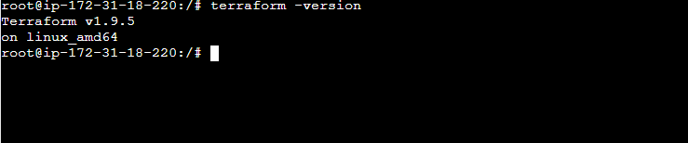

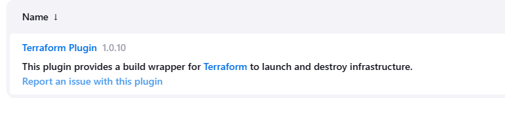

Created a sample Repository in Jenkins:

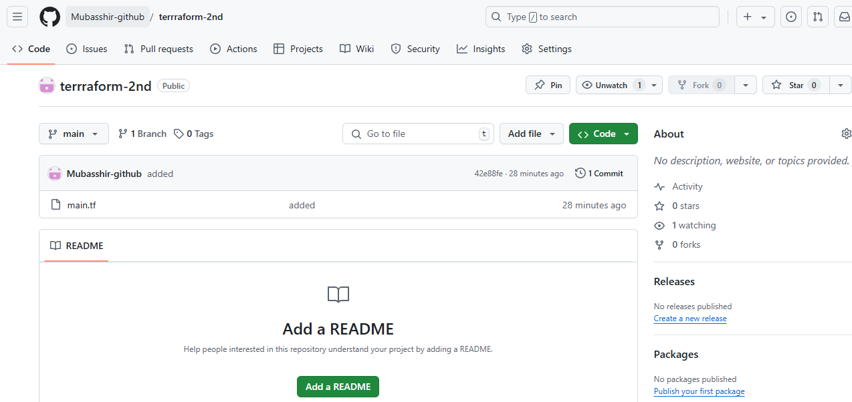

Created a shell script to execute the terraform commands:  
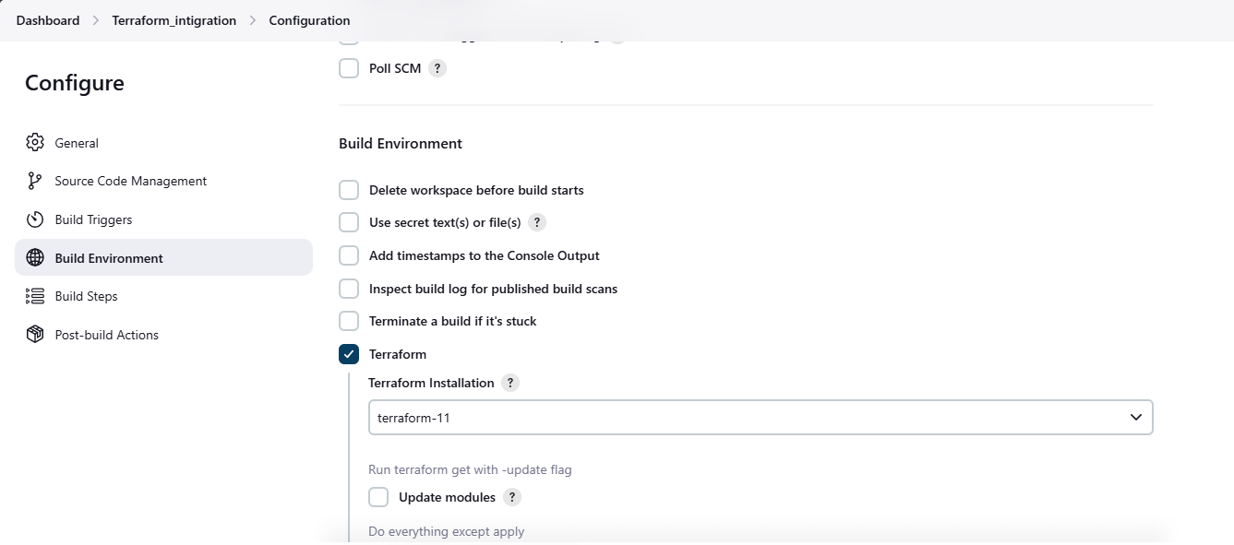  
script execution:

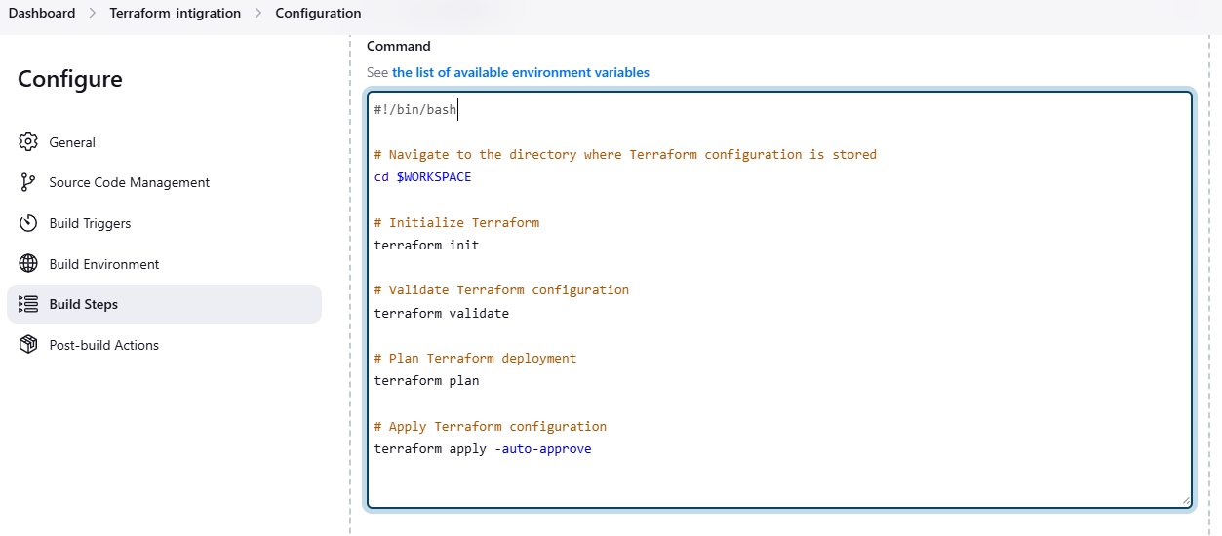  
The job has created the terraform files and integrated as well:  
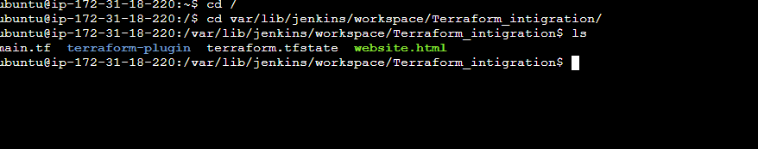

Jenkins output: 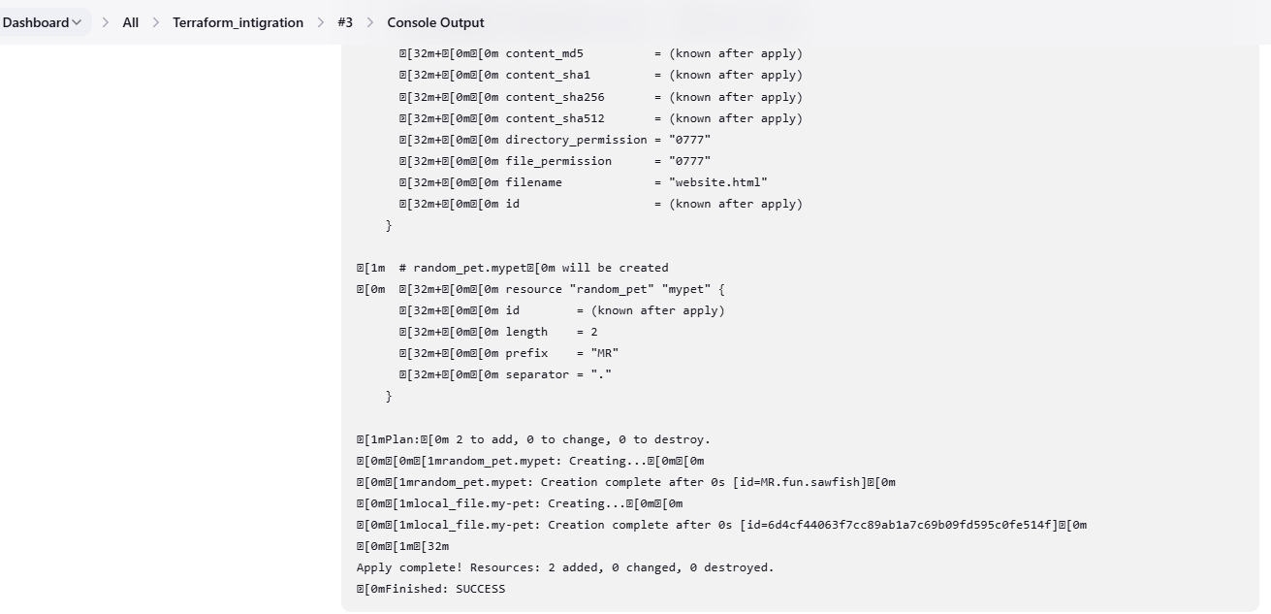

4) Create one jenkins job using MAVEN PROJECT for the below code with two stages.

Code: https://github.com/betawins/java-Working-app.git

stage 1: Git clone

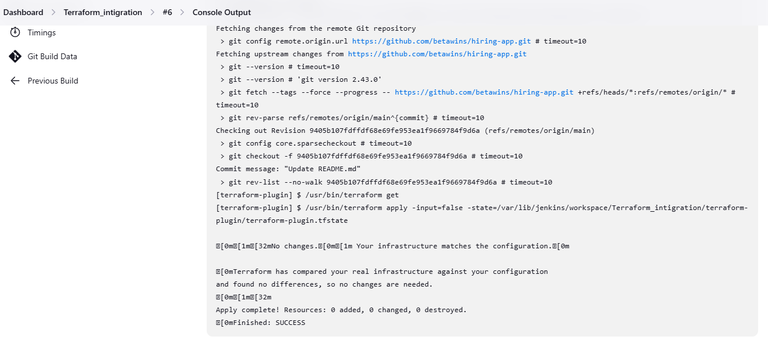

stage 2: Maven Compilation

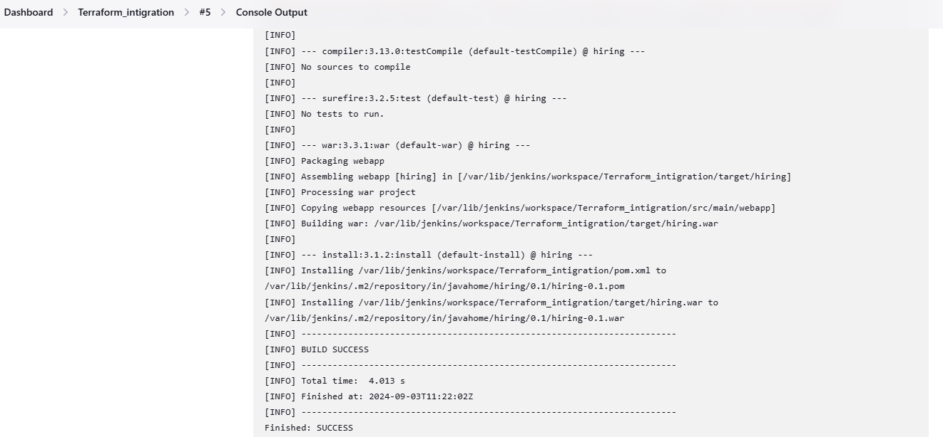

5) Use the below code and create a parameterized job in Jenkins:

Code: https://github.com/betawins/java-Working-app.git

stage 1: Git clone

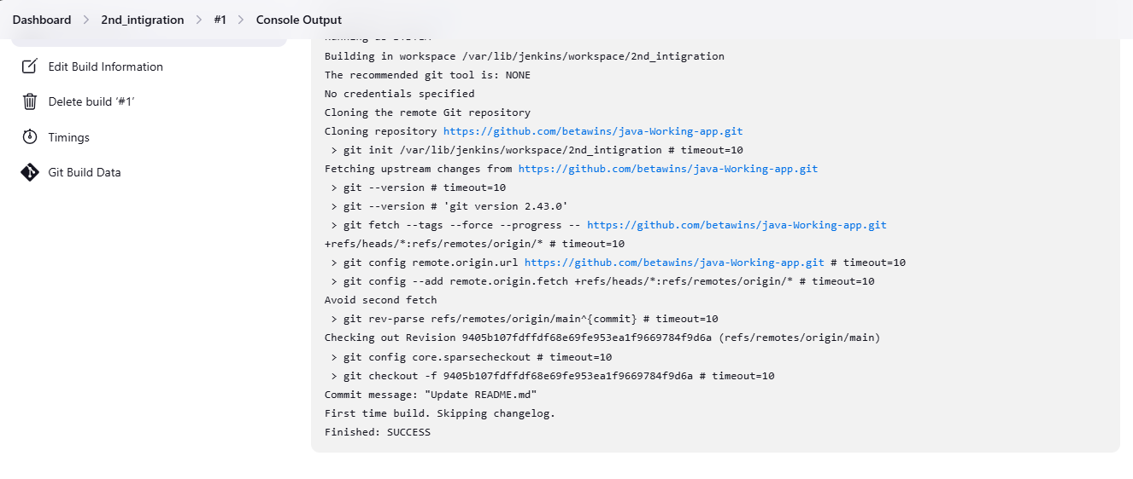

stage 2: Maven Compilation

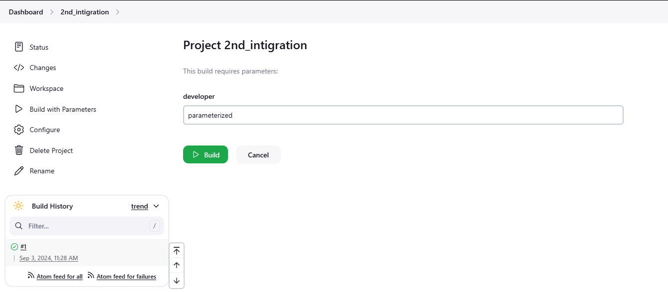 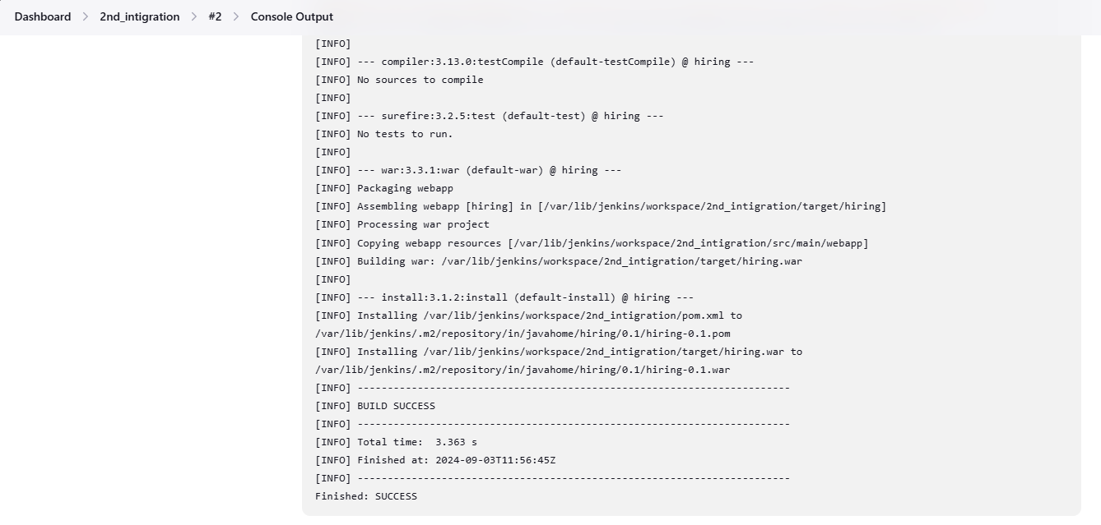

6) What are the global varaiables in jenkins?  
  
In the Jenkins pipeline, global variables are predefined objects or values accessible throughout the entire pipeline script. They’re handy tools that Jenkins provides out of the box, ready for use whenever needed. These variables contain valuable information:

Build environment data job parameters various aspects of the Jenkins system Moreover, global variables play a crucial role in making pipeline scripts more dynamic and adaptable. By leveraging these variables, we can create more flexible and reusable pipeline code.

Furthermore, global variables help maintain consistency across different pipeline scripts and make it easier to update common values across multiple jobs.